Brittney Turner

8/15/2024

Hackathon Proof Concept

**Project:** Healthcare Backend Claims

**Objective:** The purpose of this concept is to build a database that can help process backend claims to help improve the healthcare content management systems.

**Concept:** A database that uses AI to help process backend claims by implementing artificial superintelligence to reduce errors and improve efficiency.

**Technology:** The software includes AI and machine learning and MySQl while the hardware includes computer and network equipment.

**Prototype: Data insertion**

MYSQL > CREATE TABLE Hospital

*Hospital_ID*

*Full Name*

*Field Specialty*

*Full address*

MYSQL > CREATE TABLE Healthcare

*Employee_ID*

*Full Name*

*Field Specialty*

*Phone Number*

MYSQL > CREATE TABLE Patient

*Patient_ID*

*Full Name*

*Full address*

*Phone number*

MYSQL > INSERT INTO Patient (password, claim values)

VALUES ( LastNameID, $)

{

“_id” : Turner_id

“Password”: *******

“FullName” : {

“First Name”: “Brittney”

“Last Name”: “Turner”

},

“FullAddress” : 1234 frank dr

“PhoneNumber”: 234-654-0987

“ClaimValue”: $

}

Screenshot of prototype in MySQL

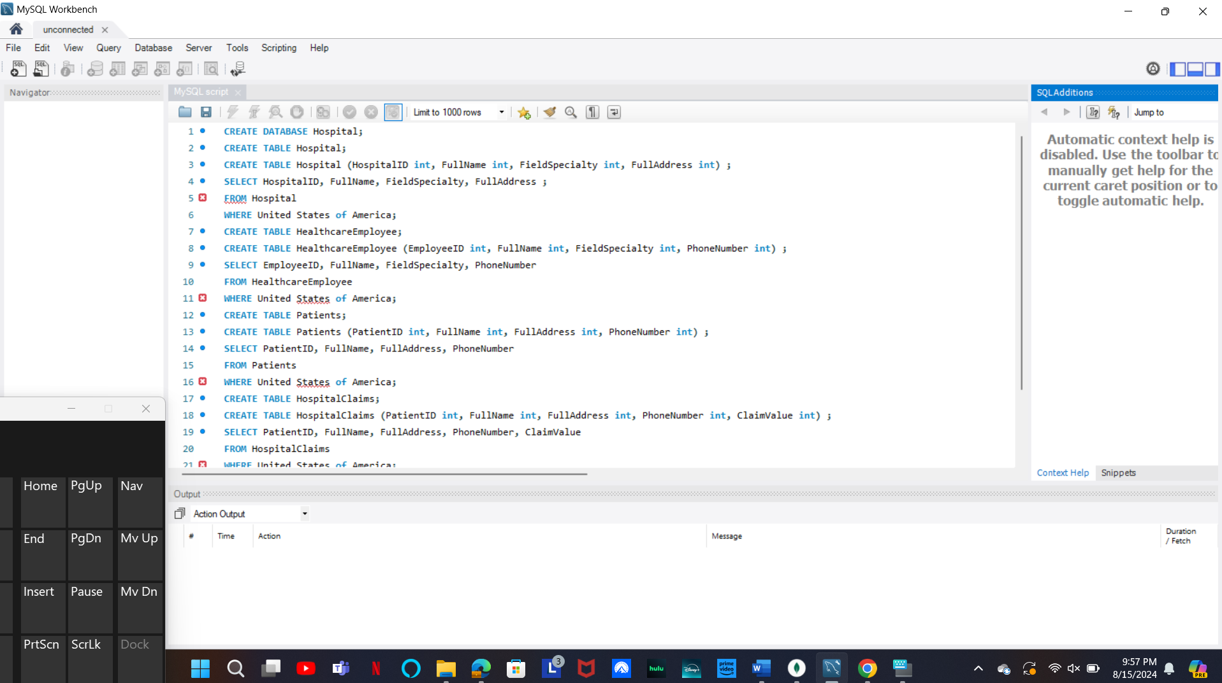

**Attached to the email is the physical copy of the database created in MySQL. Thank you!**